PricePilot AI
Title: PricePilot AI: Dynamic Pricing Optimization & Revenue Intelligence System
Milestone 1 Documentation
Requirements & Dataset Preparation
Milestone 1 (EDA, Frontend & Backend Setup, Git and GitHub Setup)

Project Objective
The objective of PricePilot AI is to build an AI-powered dynamic pricing platform that helps businesses optimize product prices based on market demand, competitor pricing, customer behaviour, and sales performance.
The system is designed to support:
- Price prediction
- Competitor pricing analysis
- Demand-based pricing
- Revenue optimization
- Promotion and discount analysis
- Pricing analytics
The platform aims to maximize revenue, improve profitability, enhance market competitiveness, and support intelligent pricing decisions using data analytics and Machine Learning.
This solution can potentially be applied to:
- E-commerce companies
- Retail businesses
- Online marketplaces
- Hotels
- Sales organizations

Dataset Details Amazon Dataset Link
- Total Records: 76,000
- Total Columns: 21
The dataset contains information related to retail operations, including sales, inventory, demand, pricing, promotions, competitor pricing, weather conditions, and other external business factors.

Categorical Features
The dataset includes categorical variables such as:
- Store ID
- Product ID
- Category
- Region
- Weather Condition
- Seasonality

Numerical Features
The dataset contains numerical variables including:
- Inventory Level
- Units Sold
- Units Ordered
- Price
- Discount
- Promotion
- Competitor Pricing
- Epidemic
- Demand
- Revenue

Time Features
The dataset contains date-related information from which the following features can be extracted:
- Year
- Month
- Day
These features can be useful for analysing sales trends and seasonal patterns.

Target Variable
The target variable depends on the specific Machine Learning objective.
Potential target variables include:
- Revenue
- Units Sold
- Demand

Process Followed
Step 1: Environment Setup
The development environment was prepared for data analysis and Machine Learning implementation.
The required Python libraries were imported:
import pandas as pd
import numpy as np
import matplotlib.pyplot as plt
import seaborn as sns
Additional Machine Learning libraries can be used in future milestones.
The following tools and technologies were used:
- Python
- Google Colab
- Pandas
- NumPy
- Matplotlib
- Seaborn
- Scikit-learn
- Creating Python Environment & Activation
- python -m venv venv
- venv\Scripts\activate
- Frontend & Backend Setup
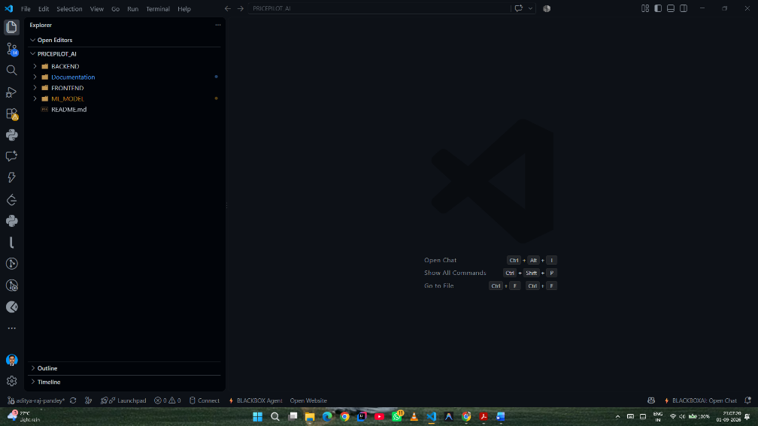

Step 2: Data Exploration

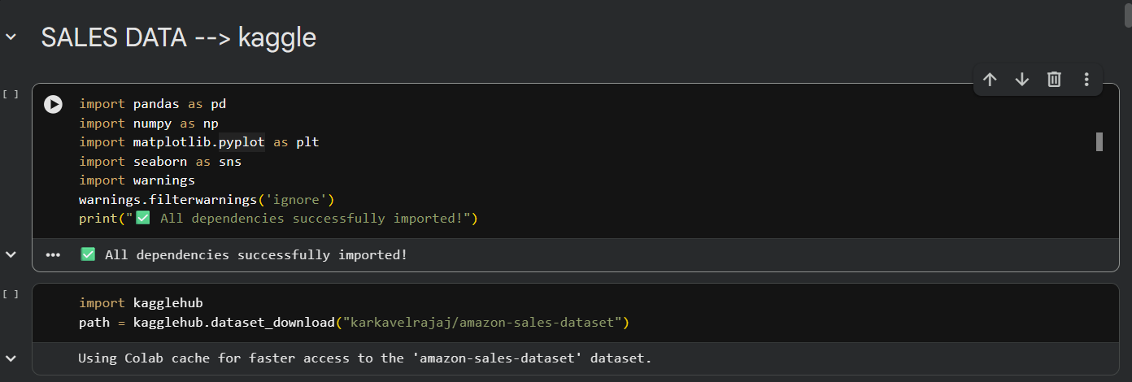

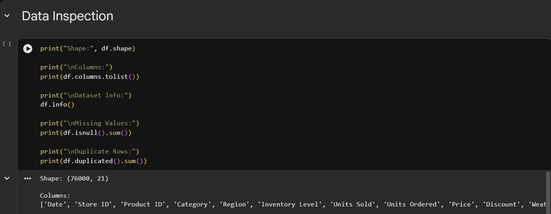

Observations
The following observations were made during initial data exploration:
- The dataset contains 76,000 records.
- The dataset contains 21 columns.
- The dataset contains both numerical and categorical variables.
- The dataset includes important business variables such as Revenue, Demand, Price, Units Sold, Discount, and Competitor Pricing.
- The dataset is suitable for detailed Exploratory Data Analysis.
- Date-related features can be used for temporal and seasonal analysis.

Results
The analysis showed:
- No missing values
- No duplicate records
Therefore, no records needed to be removed because of missing or duplicate data.

Step 4: Outlier Analysis
Outliers were analyzed using statistical methods such as the Interquartile Range (IQR).
The IQR method uses:
IQR = Q3 - Q1
The lower and upper limits are calculated as:
Lower Bound = Q1 - 1.5 × IQR
Upper Bound = Q3 + 1.5 × IQR
Outliers were observed in some numerical variables, particularly:
- Discount
- Units Ordered
- Inventory Level
- Revenue
Instead of removing a large number of records, selected outliers were handled carefully to preserve the size and information contained in the dataset.

Data Analysis (Graphs)
Graph 1: Distribution of Revenue
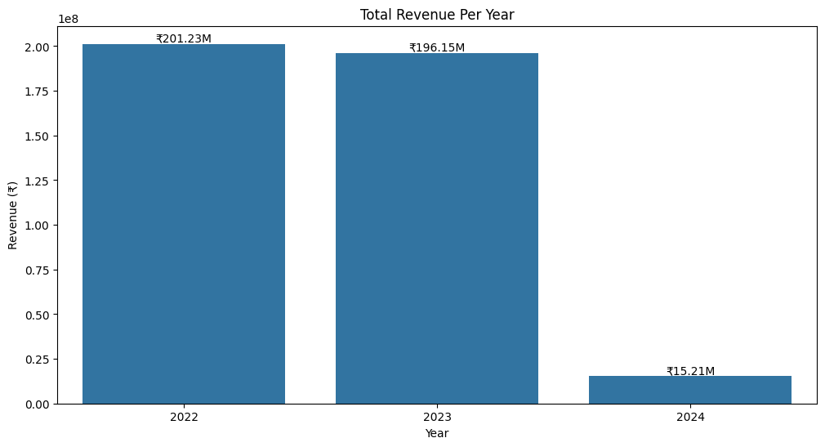
Observation
The Revenue distribution helps identify:
- The concentration of revenue values
- High and low revenue observations
- Possible skewness
- Potential outliers
This analysis provides an initial understanding of overall business performance.

Graph 2: Top Stores By revenue

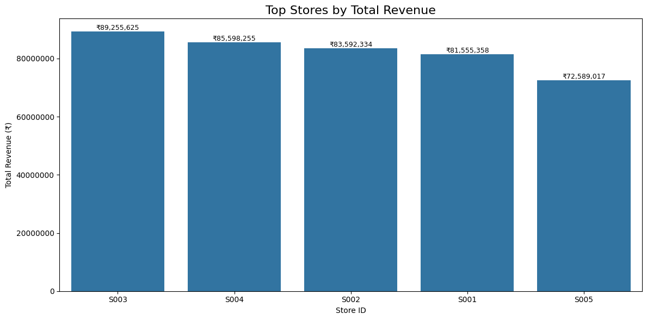

Observations
The correlation analysis revealed several important relationships.
Demand vs Units Sold
Correlation:
0.83
This represents a strong positive relationship.
Higher demand is strongly associated with higher sales.

Price vs Competitor Pricing
Correlation:
0.98
This represents an extremely strong positive relationship.
This suggests that product prices closely move with competitor pricing.

Price vs Revenue
Correlation:
0.72
This indicates a strong positive relationship between product price and revenue.

Promotion vs Discount
Correlation:
0.78
Promotions are strongly associated with discounts.

Epidemic Impact
Negative correlations were observed between epidemic conditions and:
- Demand
- Units Sold
- Revenue
This suggests that epidemic conditions may negatively affect business performance.

Graph 3: Product category Distribution

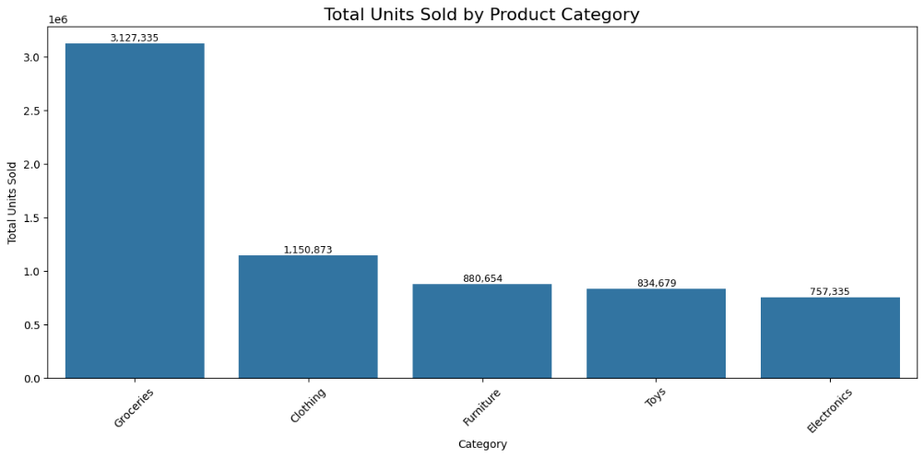

Graph:4 Discounts Analysis on Sales
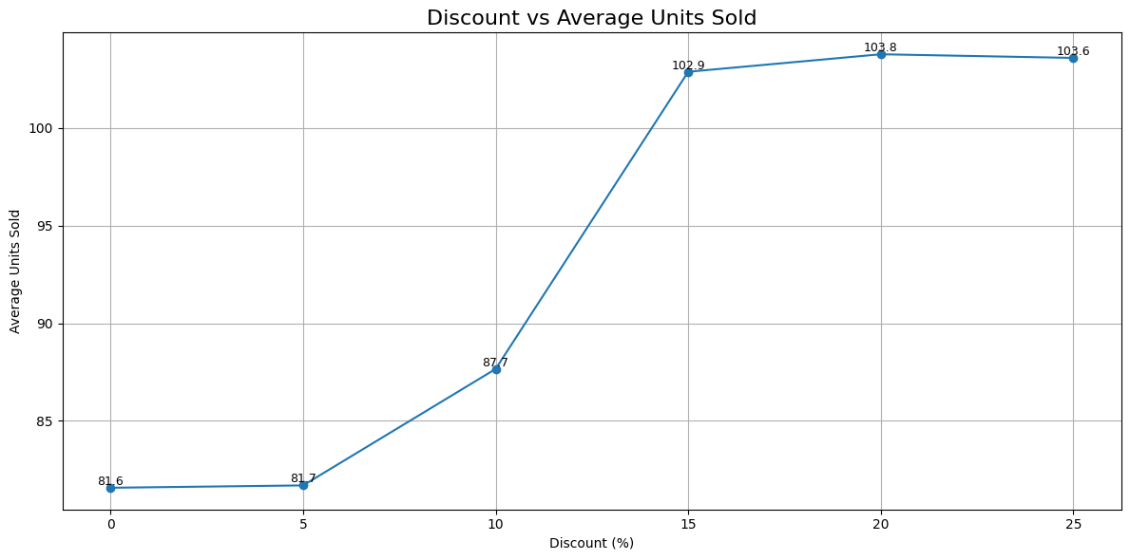

Observation
The analysis showed that:
- Low discounts have limited impact on sales.
- Sales increase significantly between 10% and 15% discounts.
- Average units sold reaches its highest level around 20% discount.
- Increasing the discount beyond 20% does not significantly increase sales.
Conclusion
This indicates diminishing returns from excessive discounts.
A discount range of approximately 15–20% appears effective for increasing sales volume.

Graph 5: Demand According to seasons
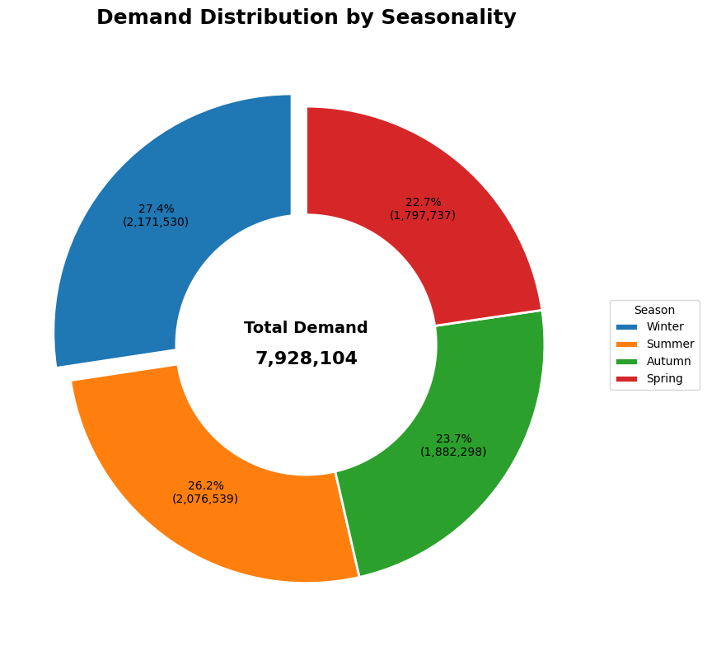

Feature Engineering
Date Feature Extraction
Date-related features can be extracted from the dataset.
df['Date'] = pd.to_datetime(df['Date'])
df['Year'] = df['Date'].dt.year
df['Month'] = df['Date'].dt.month
df['Day'] = df['Date'].dt.day
These features can help analyze:
- Monthly sales
- Yearly revenue
- Seasonal demand
- Business trends

Potential Feature Engineering
A useful feature for pricing analysis is:
Price Difference
df['Price_Difference'] = (
df['Price'] -
df['Competitor Pricing']
)
This feature can help analyze:
- Whether the company is more expensive than competitors
- Whether lower prices increase sales
- The effect of competitive pricing on revenue

Challenges Faced
The following challenges were encountered during Milestone 1:
1. Understanding the Dataset and VS code setup
2. Outlier Detection
3. Interpretation of Correlation
4. Different Metric Scales

Conclusion
Milestone 1 successfully completed the dataset exploration, cleaning, and Exploratory Data Analysis phase of the PricePilot AI project. Also, Frontend and Backend setup also Done.

Submitted By:
Aditya Raj Pandey
Email: 2k23.psitaiml2311215@gmail.com
PricePilot AI: Dynamic Pricing Optimization & Revenue Intelligence System

